## 

## 

**Experiment 4:**

**Using Software Tools and Code Versioning System**

CPE106L (Software Design Laboratory)

**Ju Hyoung Lee**

**John Paulo D. Fernandez**

**Neal Reine D. Taguiam**

Group No.: **7**

Section: **B2**

## **PreLab**



|  |
| --- |
| **Readings, Insights, and Reflection**Top of Form  Lee, Fernandez, and Taguiam  The fourth lab activity discusses how we can create desktop applications and perform unit testing. In creating the desktop application, the main focus was organizing, constructing, and enhancing command-line applications and using third-party frameworks such as Tkinter to provide more choices to the user in creating their GUI. For this lab activity, the group is tasked to test desktop applications, specifically the Tic-Tac-Toe game, for console and GUI formats.            As we prepared for the lab activity, it became apparent to our group that developing desktop applications is an essential aspect of software development. We must ensure that the desktop application being developed will be high quality, reliable, and answer the users' needs. Furthermore, by conducting unit testing, we can ensure that the application will be able to have those attributes. We perform unit testing to check the individual sections and verify whether each part is properly functioning. This phase holds significant importance in the software development life cycle as it aids in the early detection of errors and flaws in the program before they escalate into significant issues later. Besides enhancing code quality, unit testing can expedite the development process by identifying problems early, thereby reducing the need for extensive debugging and testing in the long run. This, in turn, can lead to a reduction in overall development time and enhance development efficiency. Various tools and frameworks are available for unit testing during desktop application development, with Tkinter being one of the most widely used, as discussed in the provided materials.           In summary, understanding the structuring, development, and expansion of command-line applications makes it possible for the group to create and enhance desktop applications, particularly in Python. The software was also subjected to appropriate coding system structure testing. All these principles and methodologies were applied to execute the Tic-Tac-Toe console application and GUI and test their functio |
|  |

## **InLab**



[**What to Include?]**

* **Objectives** (See Lab guide).

1. Objective 1
2. Objective 2

* **Tools Used** 
  + Anaconda
  + Git Terminal
* **Procedure.** Steps Performed with edited screenshots of tools used (Example: Using Anaconda, sample run, debugging with **DISCUSSIONS** (DON’T copy and paste from the ebook)**.** Use the source in the Lab Guide. You may include source codes of Roth. **IMPORTANT**: Figure numbers and labels. Mention the figure in your discussion.

|  |
| --- |
| <Discussion placeholder>  Lorem ipsum dolor sit amet, consectetur adipiscing elit, sed do eiusmod tempor incididunt ut labore et dolore magna aliqua. Ut enim ad minim veniam, quis nostrud exercitation ullamco laboris nisi ut aliquip ex ea commodo consequat.  Figure 1. Using conda command to display created environments. There are seven conda environments.  Duis aute irure dolor in reprehenderit in voluptate velit esse cillum dolore eu fugiat nulla pariatur. Excepteur sint occaecat cupidatat non proident, sunt in culpa qui officia deserunt mollit anim id est laborum.  Lorem ipsum dolor sit amet, consectetur adipiscing elit, sed do eiusmod tempor incididunt ut labore et dolore magna aliqua. Ut enim ad minim veniam, quis nostrud exercitation ullamco laboris nisi ut aliquip ex ea commodo consequat. Duis aute irure dolor in reprehenderit in voluptate velit esse cillum dolore eu fugiat nulla pariatur. Excepteur sint occaecat cupidatat non proident, sunt in culpa qui officia deserunt mollit anim id est laborum. |

Duis aute irure dolor in reprehenderit in voluptate velit esse cillum dolore eu fugiat nulla pariatur. Excepteur sint occaecat cupidatat non proident, sunt in culpa qui officia deserunt mollit anim id est laborum.

Lorem ipsum dolor sit amet, consectetur adipiscing elit, sed do eiusmod tempor incididunt ut labore et dolore magna aliqua. Ut enim ad minim veniam, quis nostrud exercitation ullamco laboris nisi ut aliquip ex ea commodo consequat. Duis aute irure dolor in reprehenderit in

Duis aute irure dolor in reprehenderit in voluptate velit esse cillum dolore eu fugiat nulla pariatur. Excepteur sint occaecat cupidatat non proident, sunt in culpa qui officia deserunt mollit anim id est laborum.

Lorem ipsum dolor sit amet, consectetur adipiscing elit, sed do eiusmod tempor incididunt ut labore et dolore magna aliqua. Ut enim ad minim veniam, quis nostrud exercitation ullamco laboris nisi ut aliquip ex ea commodo consequat. Duis aute irure dolor in reprehenderit in

## **PostLab**



[**What to Include?]**

**Programming Problems** (Leaders will assign each member to work on)

Includes edited screenshots of tools used (Using Anaconda, Git Terminal, and Visual Studio Code sample run, debugging with **DISCUSSIONS** (DON’T copy and paste from the ebook)**.** Use the source in the Lab Guide. You may include source codes of Roth. **IMPORTANT**: Figure numbers and labels. Mention the figure in your discussion.

***<Discussions here…>***

Lorem ipsum dolor sit amet, consectetur adipiscing elit, sed do eiusmod tempor incididunt ut labore et dolore magna aliqua. Ut enim ad minim veniam, quis nostrud exercitation ullamco laboris nisi ut aliquip ex ea commodo consequat.

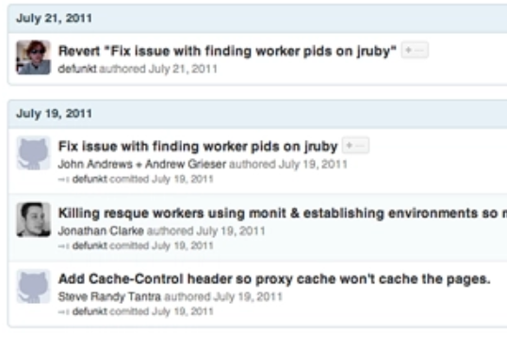

Figure 2. Adding commit message.

Duis aute irure dolor in reprehenderit in voluptate velit esse cillum dolore eu fugiat nulla pariatur. Excepteur sint occaecat cupidatat non proident, sunt in culpa qui officia deserunt mollit anim id est laborum.

Lorem ipsum dolor sit amet, consectetur adipiscing elit, sed do eiusmod tempor incididunt ut labore et dolore magna aliqua. Ut enim ad minim veniam, quis nostrud exercitation ullamco laboris nisi ut aliquip ex ea commodo consequat. Duis aute irure dolor in reprehenderit in voluptate velit esse cillum dolore eu fugiat nulla pariatur. Excepteur sint occaecat cupidatat non proident, sunt in culpa qui officia deserunt mollit anim id est laborum.